

RAMAIAH
INSTITUTE OF TECHNOLOGY
USN | 1 | M | S

(Autonomous Institute, Affiliated to VTU)
Bangalore – 560 054

SEMESTER END EXAMINATIONS – JANUARY 2017

Course & Branch | : | B.E : Common to all branches | Semester | : | I/II
Subject | : | Basic Electronics | Max. Marks | : | 100
Subject Code | : | EC101/EC201 | Duration | : | 3 Hrs

Instructions to the Candidates:
- Answer one full question from each unit.

 |  | UNIT- I
1. | a) | Determine the diode current at 20⁰C for a silicon diode with I_{s} = 50nA and applied forward bias of 0.6V. Take η=2. Find the current if the applied voltage is changed to 0.22. Take η=1. | CO1 | (07)
 | b) | With necessary equations, show that the efficiency of a full wave rectifier with center tapped transformer is 81.2%. Also find its PIV. | CO1 | (08)
 | c) | Explain the working of CE transistor amplifier with suitable example. | CO1 | (05)
2. | a) | A full wave bridge rectifier with 120V rms, f=50Hz, sinusoidal input has a load resistor of 1KΩ. If silicon diodes are employed, find the dc voltage available at load. Assuming ideal diodes, calculate the average load current and ripple voltage if a capacitor value of 200µF is connected across the load. | CO1 | (07)
 | b) | Determine V_{out} for each network shown and identify the network.  i)  ii)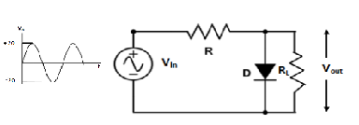  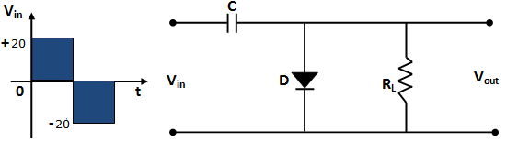 | CO1 | (06)
 | c) | Draw the circuit of a common emitter configuration and explain the input and output characteristics with neat waveforms. | CO1 | (07)
 |  | UNIT - II
3. | a) | A voltage divider bias circuit has R₁=33KΩ, R₂=10KΩ, R_{C}=2.2KΩ, R_{E}=1KΩ, V_{CC}=20V, h_{FE}=100. Calculate V_{B}, V_{E}, I_{E}, I_{B}, I_{C}, V_{C} and V_{CE} and also draw DC load line and mark Q-point. Assume V_{BE}=0.7V | CO2 | (08)
 | b) | With neat circuit diagram, explain the operation of op-amp inverting amplifier. | CO2 | (06)
 | c) | Explain how op-amp can be used as differentiator with circuit diagram and equations. Write its applications. | CO2 | (06)
4. | a) | Define biasing in transistor. Explain Base Bias Circuit with a neat circuit diagram and necessary equations. | CO2 | (06)
 | b) | Compare the ideal characteristics of operational amplifier with practical characteristics. | CO2 | (06)
 | c) | Describe how op-amp can be used as subtractor circuit and prove that  V₀=V₂−V₁ | CO2 | (08)
 |  | UNIT- III
5. | a) | Design and realize Full Adder circuit using two half adders. | CO3 | (07)
 | b) | Perform the following clearly showing all the steps:  i) (C8.B9)₁₆ ₌ ( ? ) ₁₀ ₌ ( ? ) ₂ ₌ ( ? )₈  ii) (56)₁₀ – (74)₁₀ using 1’s and 2’s complement Binary subtraction. | CO3 | (07)
 | c) | Simplify the given expression using Boolean laws and then realize using NAND gates only:  F= ( A +‾B C) (‾A + B + ‾C ) ( A +‾B ) (A‾B C+B) | CO3 | (06)
6. | a) | Realize basic gates using only NOR gates. | CO3 | (07)
 | b) | Perform the following clearly showing all the steps:  i) (1111001.00110)₂ ₌ ( ? ) ₁₆ ₌ ( ? ) ₁₀ ₌ ( ? )₈  ii) (1100.10)₂ – (1101.01)₂ using 1’s and 2’s complement subtraction. | CO3 | (07)
 | c) | 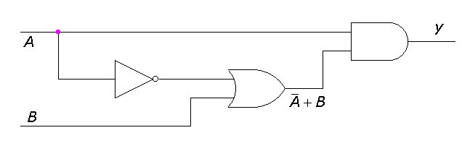  For the circuit given obtain the simplified Boolean expression. | CO3 | (06)
 |  | UNIT - IV
7. | a) | Compare combinational logic circuit and sequential logic circuit with example. | CO4 | (06)
 | b) | With neat sketches, explain the operation of NAND gate latch and NOR gate latch. | CO4 | (08)
 | c) | Explain the different flags in 8051 Microcontroller. | CO4 | (06)
8. | a) | Explain the operation of clocked RS-Flip Flop with circuit, functional table and timing diagram. | CO4 | (06)
 | b) | Differentiate between Microprocessor and Microcontroller. | CO4 | (06)
 | c) | With neat block diagram explain the architecture of 8051 Microcontroller. | CO4 | (08)
 |  | UNIT - V
9. | a) | Define Modulation. Mention the advantage of modulation. | CO5 | (06)
 | b) | Derive an expression for the power output in an AM transmitter and hence determine the carrier power when the AM transmitter produces 10kW with a Modulation percentage of 75. | CO5 | (08)
 | c) | What are transducers? Bring out the differences between active and passive transducers. | CO5 | (06)
10. | a) | Define the terms Amplitude modulation, frequency and phase modulation. | CO5 | (06)
 | b) | Explain the working of Linear variable Differential Transformer with neat diagram. | CO5 | (08)
 | c) | Explain the working principle of thermistor. | CO5 | (06)
****************

